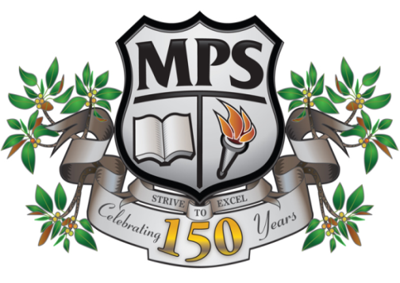
Protecting and Supporting Children and Young People Policy
Morpeth Public School
2018
Implementation Procedures
- At the beginning of each school year, all staff ( Teaching and SASS ) will be trained in current Child Protection procedures
- Child Protection Awareness induction training for new staff
- Training will include all mandatory update modules
- Training will be implemented and completed within designated time frames
- The training will be scheduled as an Event on MyPL which will provide a record of completion for all attending staff.
- Document listing staff who have completed mandatory Child Protection training will be filed in ‘Mandatory Training’ - folder of evidence – stored in Administration Office.
- Training will take place on Staff Development Day of Term 1 or, if not scheduled for this day, completed within required time frames or in the event of new staff being employed at the school
- Child Protection training will be delivered by Principal or a delegate of the Principal (Assistant Principal or Relieving Principal ) .
Training will include:
- Use of mandatory documents, including Mandatory Reporter Guide www.keepthemsafe.nsw.gov.au
- Completion of modules ( where applicable )
- Group discussion regarding scenarios and actions
- a general overview of reporting requirements and processes
- Refer to family and Community Services http://www.community.nsw.gov.au/

N.B
- All resources relating to the Child Protection training will be uploaded to the school’s intranet and filed under ‘Child Protection.’
- Training will be conducted annually or as required ( updates )
- All executive staff will be trained in implementation procedures
In the event of concerns about a student – process and procedure
- Report immediately to Principal ( or delegate )
- Principal uses Mandatory Reporter Guide – or acts on professional judgement
- Principal or delegate contacts Child Protection Hotline 133627 in the event of suspected significant harm
- For all other suspected risk of harm or for clarification Principal or delegate will phone Child Wellbeing Unit – 92699400
- Records of all incidents will be filed in Principal’s Office in file labelled Child Protection
